Instructions for setting up and running agents on the LangChain cloud
Getting Set Up
Introduction
Welcome to LangChain Academy’s LangChain Essentials - Python course!
Please refer to the following sections to prepare your system to run the notebooks provided.
Note: If you choose a different model from what is used in the notebook you may get unexpected results.
🚀 Setup
Prerequisites
- The Chrome browser is recommended
- git is recommended
- uv package manager or pip
- The course requires Python >=3.11, <3.14 If you use uv, it will take care of this for you.
- Node.js and npx (required for MCP server in notebook 5):
# Install Node.js (includes npx)
# On macOS with Homebrew:
brew install node

# On Ubuntu/Debian:
curl -fsSL https://deb.nodesource.com/setup_lts.x | sudo -E bash -
sudo apt-get install -y nodejs

# Verify installation:
node --version
npx --version
Installation
Download the course repository
# Clone the repo, cd to 'python' directory
git clone https://github.com/langchain-ai/lca-langchainV1-essentials.git
cd ./lca-langchainV1-essentials/python
Make a copy of example.env
# Create .env file
cp example.env .env
Insert API keys directly into .env file, OpenAI (required) and LangSmith (optional)
# Add OpenAI API key
OPENAI_API_KEY=your_openai_api_key_here
# The course is written with OpenAI models, but you can choose others if you prefer.
# Be sure to add the key and modify the code to call your preferred model
#ANTHROPIC_API_KEY=your_anthropic_api_key_here_if_you_prefer

# Optional API key for LangSmith tracing
LANGSMITH_API_KEY=your_langsmith_api_key_here
LANGSMITH_TRACING=true
LANGSMITH_PROJECT=langchain-py-essentials
# If you are on the EU instance:
LANGSMITH_ENDPOINT=https://eu.api.smith.langchain.com
Make a virtual environment and install dependencies
# Create virtual environment and install dependencies
uv sync
Run notebooks
# Run Jupyter notebooks directly with uv
uv run jupyter lab

# Or activate the virtual environment if preferred
source .venv/bin/activate # On Windows: .venv\Scripts\activate
jupyter lab
Optional: Setup LangSmith Studio
# copy the .env file you created above to the studio directory
cp .env ./studio/.
cd studio
#to run with uv
uv run langgraph dev
#to run with virtual env
langgraph dev
Getting Started with LangSmith
- Create a LangSmith account
- Create a LangSmith API key 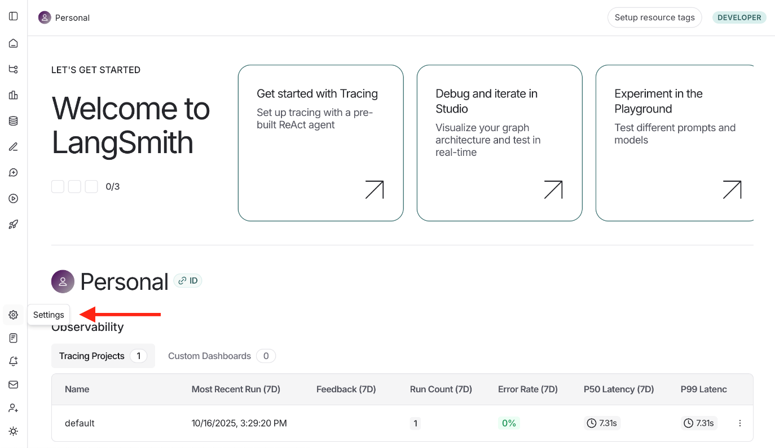 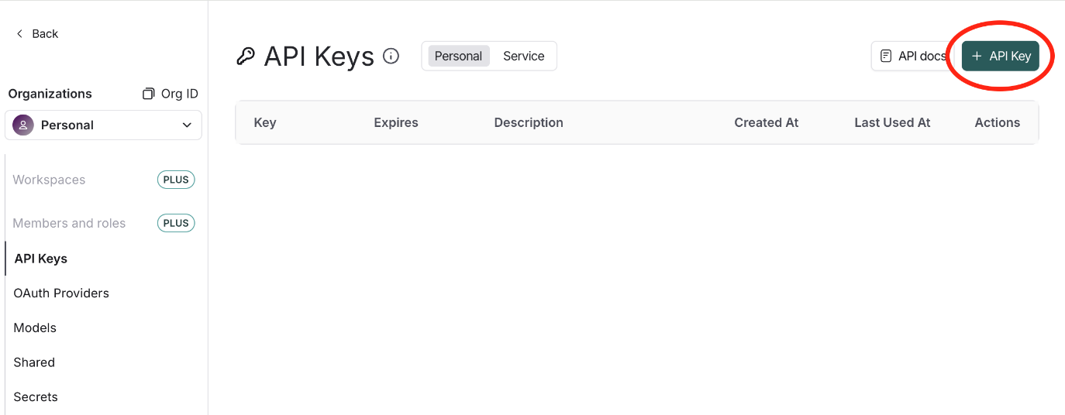
📚 Lessons
This repository contains nine short notebooks that serve as brief introductions to many of the most-used features in LangChain, starting with the new Create Agent.
L1_fast_agent.ipynb - 🤖 Create Agent 🤖
- In this notebook, you will use LangChain’s create_agent to build an SQL agent in just a few lines of code.
- It demonstrates how quick and easy it is to build a powerful agent. You can easily take this agent and apply it to your own project.
- You will also use LangSmith Studio, a handy visual debugger to run, host, and explore agents.
L2-7.ipynb - 🧱 Building Blocks 🧱
In Lessons 2–7, you will learn how to use some of the fundamental building blocks in LangChain. These lessons explain and complement create_agent, and you’ll find them useful when creating your own agents. Each lesson is concise and focused.
- L2_messages.ipynb: Learn how messages convey information between agent components.
- L3_streaming.ipynb: Learn how to reduce user-perceived latency using streaming.
- L4_tools.ipynb: Learn basic tool use to enhance your model with custom or prebuilt tools.
- L5_tools_with_mcp.ipynb: Learn to use the LangChain MCP adapter to access the world of MCP tools.
- L6_memory.ipynb: Learn how to give your agent the ability to maintain state between invocations.
- L7_structuredOutput.ipynb: Learn how to produce structured output from your agent.
L8-9.ipynb - 🪛 Customize Your Agent 🤖
Lessons 2–7 covered out-of-the-box features. However, create_agent also supports both prebuilt and user-defined customization through Middleware. This section describes middleware and includes two lessons highlighting specific use cases.
- L8_dynamic.ipynb: Learn how to dynamically modify the agent’s system prompt to react to changing contexts.
- L9_HITL.ipynb: Learn how to use Interrupts to enable Human-in-the-Loop interactions.

GETTING SET UP - LOCAL MODELS
🚀 Setup
Prerequisites
- The Chrome browser is recommended
- git is recommended
- uv package manager or pip
- The course requires Python >=3.11, <3.14 If you use uv, it will take care of this for you.
- Node.js and npx (required for MCP server in notebook 5):
# Install Node.js (includes npx)
# On macOS with Homebrew:
brew install node

# On Ubuntu/Debian:
curl -fsSL https://deb.nodesource.com/setup_lts.x | sudo -E bash -
sudo apt-get install -y nodejs

# Verify installation:
node --version
npx --version
- You can install ollama from ollama.com. After installing, make sure to pull a model (e.g., gpt-oss) to run locally:
# Pull the gpt-oss model (only need to do this once)
ollama pull gpt-oss

# Start the model locally
ollama run gpt-oss

# Check that it's running
ollama ps
Installation
Download the course repository
# Clone the repo, cd to 'python_local' directory
git clone https://github.com/langchain-ai/lca-langchainV1-essentials.git
cd ./lca-langchainV1-essentials/python_local
Make a copy of example.env
# Create .env file
cp example.env .env
Note: The OPENAI_API_KEY is not required if only Ollama models are used.
Insert API keys directly into .env file, OpenAI and LangSmith (optional)
# Add OpenAI API key
OPENAI_API_KEY=your_openai_api_key_here
# The course is written with OpenAI models, but you can choose others if you prefer.
# Be sure to add the key and modify the code to call your preferred model
#ANTHROPIC_API_KEY=your_anthropic_api_key_here_if_you_prefer

# Optional API key for LangSmith tracing
LANGSMITH_API_KEY=your_langsmith_api_key_here
LANGSMITH_TRACING=true
LANGSMITH_PROJECT=langchain-py-essentials
# If you are on the EU instance:
LANGSMITH_ENDPOINT=https://eu.api.smith.langchain.com
Make a virtual environment and install dependencies
# Create virtual environment and install dependencies
uv sync
Run notebooks
# Run Jupyter notebooks directly with uv
uv run jupyter lab

# Or activate the virtual environment if preferred
source .venv/bin/activate # On Windows: .venv\Scripts\activate
jupyter lab
Optional: Setup LangSmith Studio
# copy the .env file you created above to the studio directory
cp .env ./studio/.
cd studio
#to run with uv
uv run langgraph dev
#to run with virtual env
langgraph dev
Getting Started with LangSmith
- Create a LangSmith account
- Create a LangSmith API key
📚 Lessons
This repository contains nine short notebooks that serve as brief introductions to many of the most-used features in LangChain, starting with the new Create Agent.
L1_fast_agent.ipynb - 🤖 Create Agent 🤖
- In this notebook, you will use LangChain’s create_agent to build an SQL agent in just a few lines of code.
- It demonstrates how quick and easy it is to build a powerful agent. You can easily take this agent and apply it to your own project.
- You will also use LangSmith Studio, a handy visual debugger to run, host, and explore agents.
L2-7.ipynb - 🧱 Building Blocks 🧱
In Lessons 2–7, you will learn how to use some of the fundamental building blocks in LangChain. These lessons explain and complement create_agent, and you’ll find them useful when creating your own agents. Each lesson is concise and focused.
- L2_messages.ipynb: Learn how messages convey information between agent components.
- L3_streaming.ipynb: Learn how to reduce user-perceived latency using streaming.
- L4_tools.ipynb: Learn basic tool use to enhance your model with custom or prebuilt tools.
- L5_tools_with_mcp.ipynb: Learn to use the LangChain MCP adapter to access the world of MCP tools.
- L6_memory.ipynb: Learn how to give your agent the ability to maintain state between invocations.
- L7_structuredOutput.ipynb: Learn how to produce structured output from your agent.
L8-9.ipynb - 🪛 Customize Your Agent 🤖
Lessons 2–7 covered out-of-the-box features. However, create_agent also supports both prebuilt and user-defined customization through Middleware. This section describes middleware and includes two lessons highlighting specific use cases.
- L8_dynamic.ipynb: Learn how to dynamically modify the agent’s system prompt to react to changing contexts.
- L9_HITL.ipynb: Learn how to use Interrupts to enable Human-in-the-Loop interactions.

